DBMS – LAB -02

**NAME** : RAHUL VARMA

**ROLL NO**: S20200010212

**SECTION**: C

**TASK:** (LAB EXERCISES)

SQL COMMANDS

1. DDL COMMANDS

2. DML COMMANDS

EXERCISE 1:

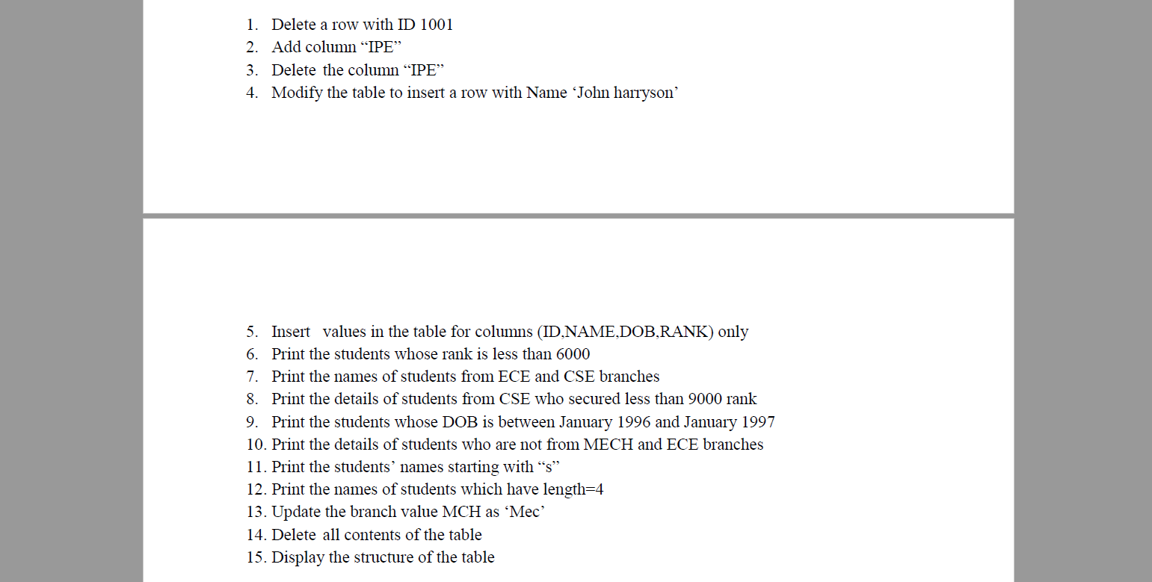

Table insertion(given table):

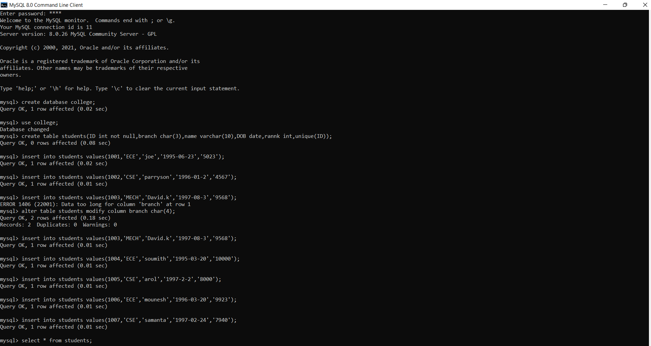

Question 1 and 2:

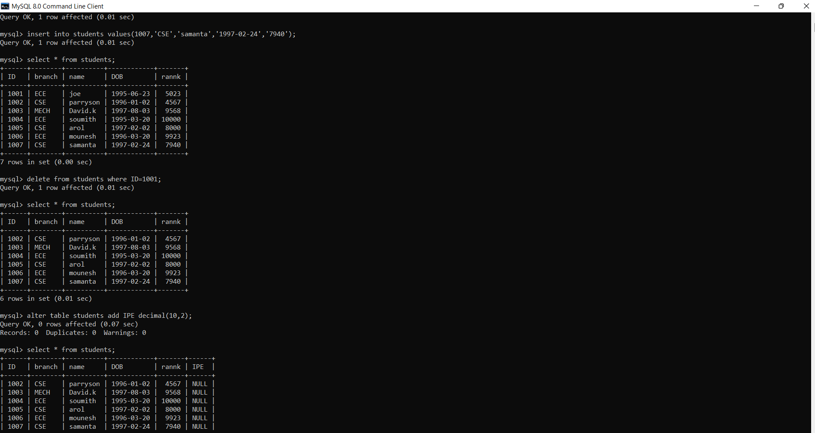

Question 3 to 7:

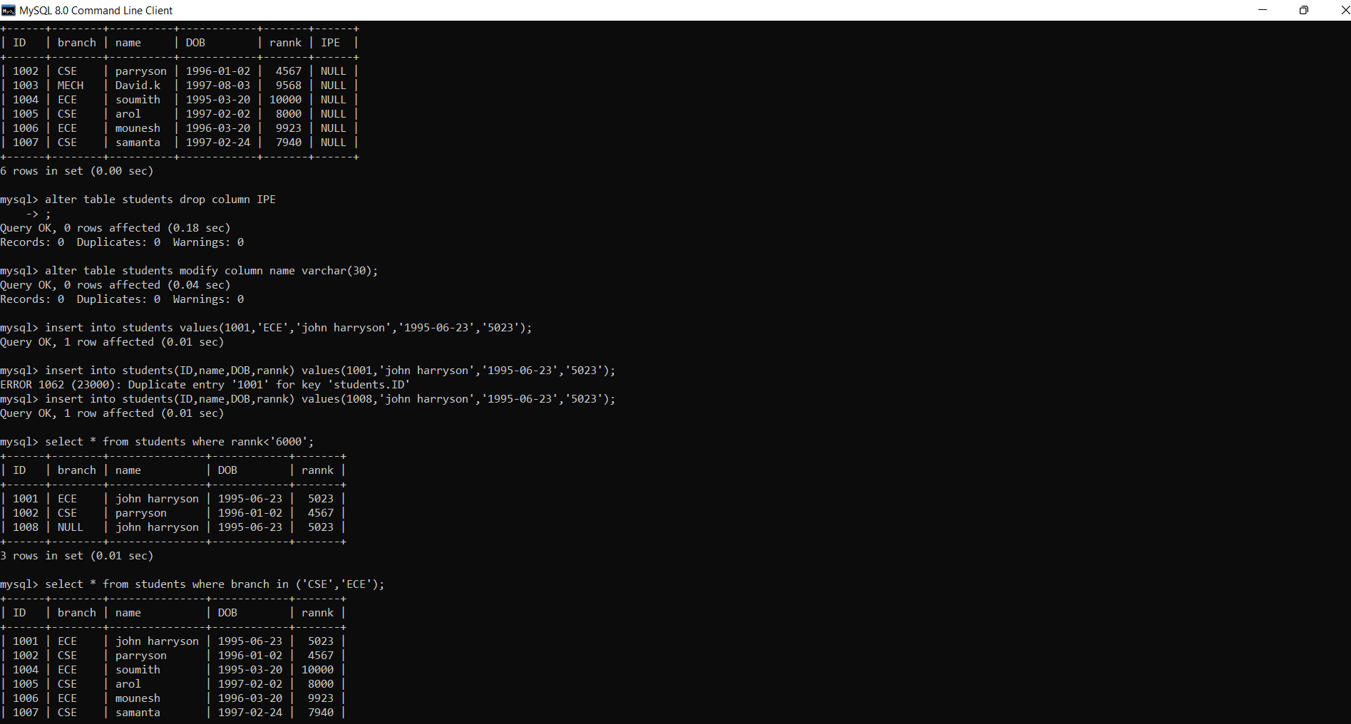

Question 8 to 10:

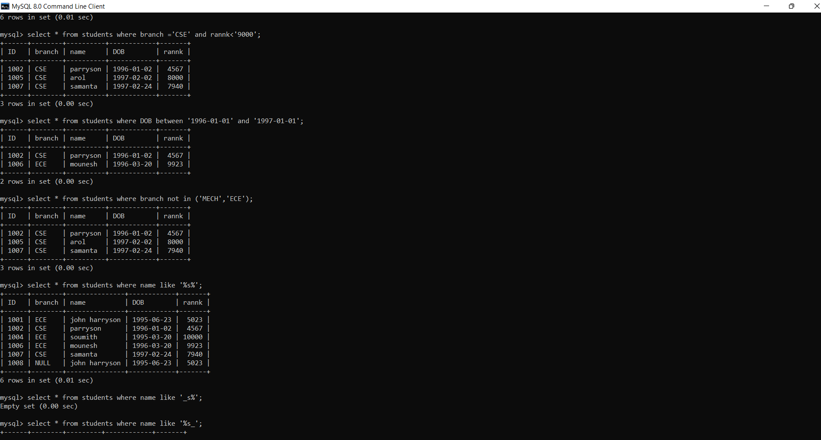

Question 11 to 13:

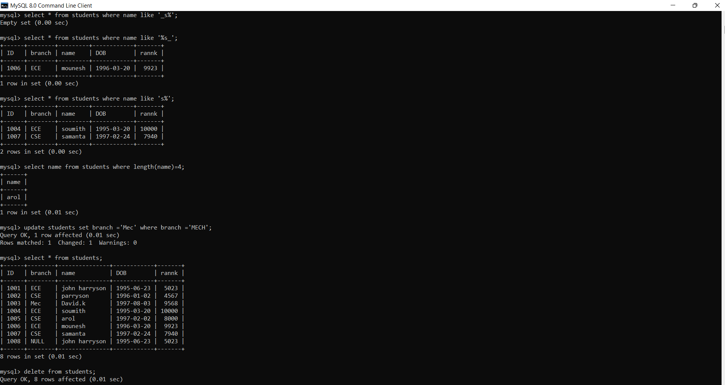

Question 14 and 15:

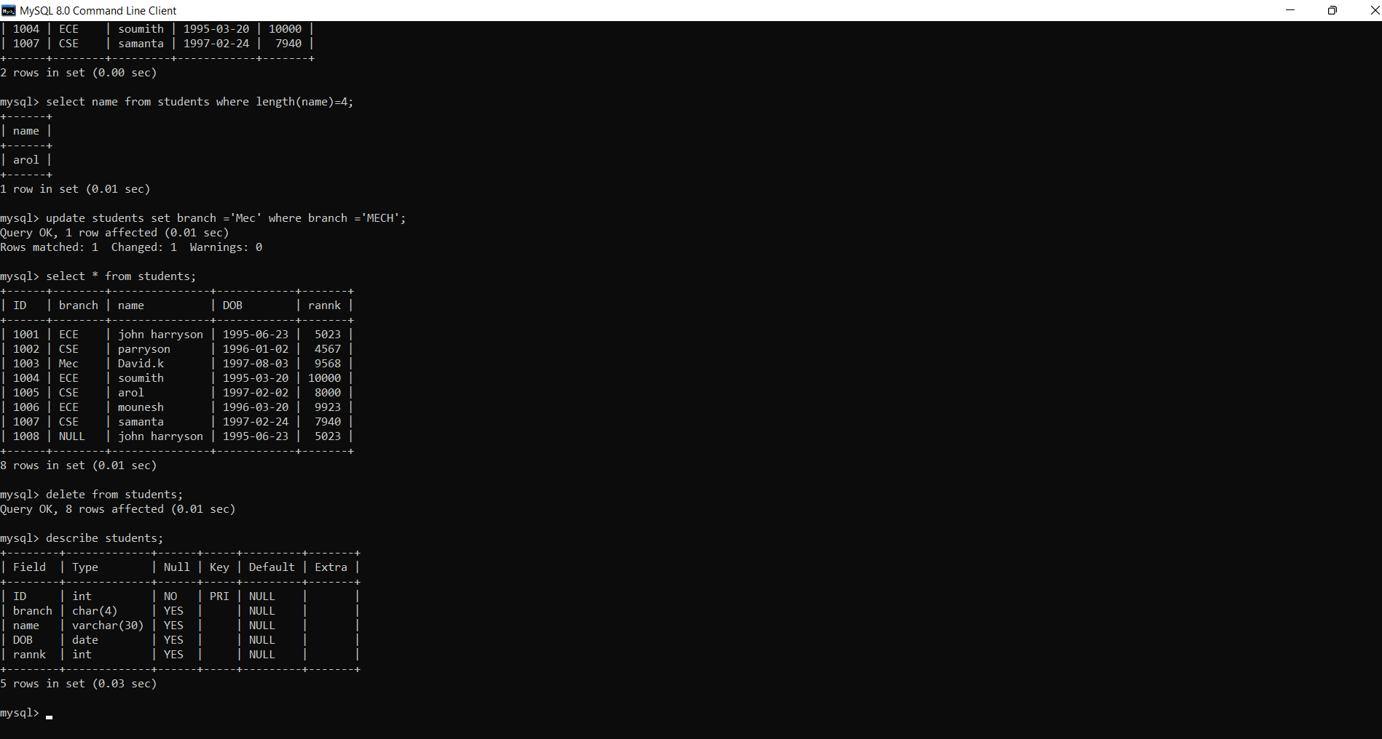

Exercise 2: 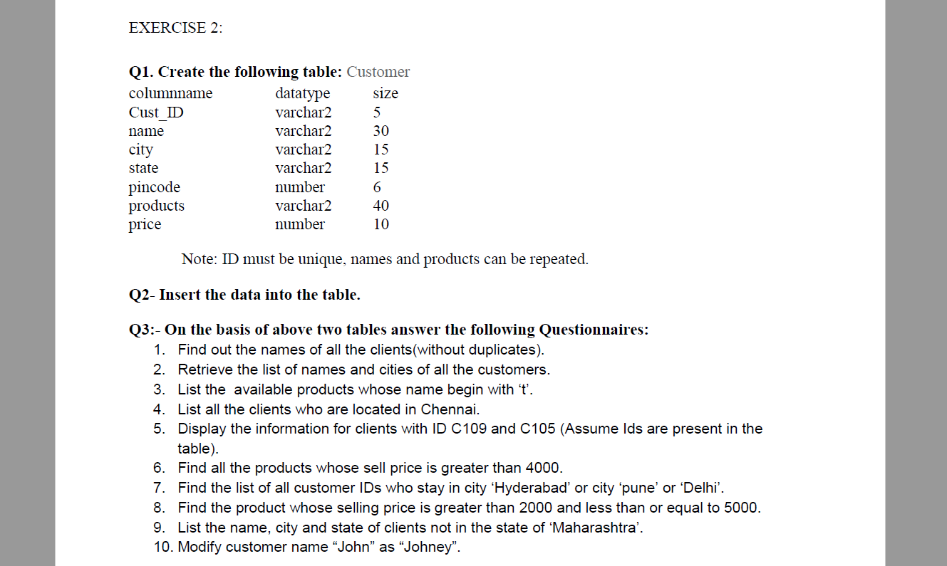

Question 1: (Creating table)

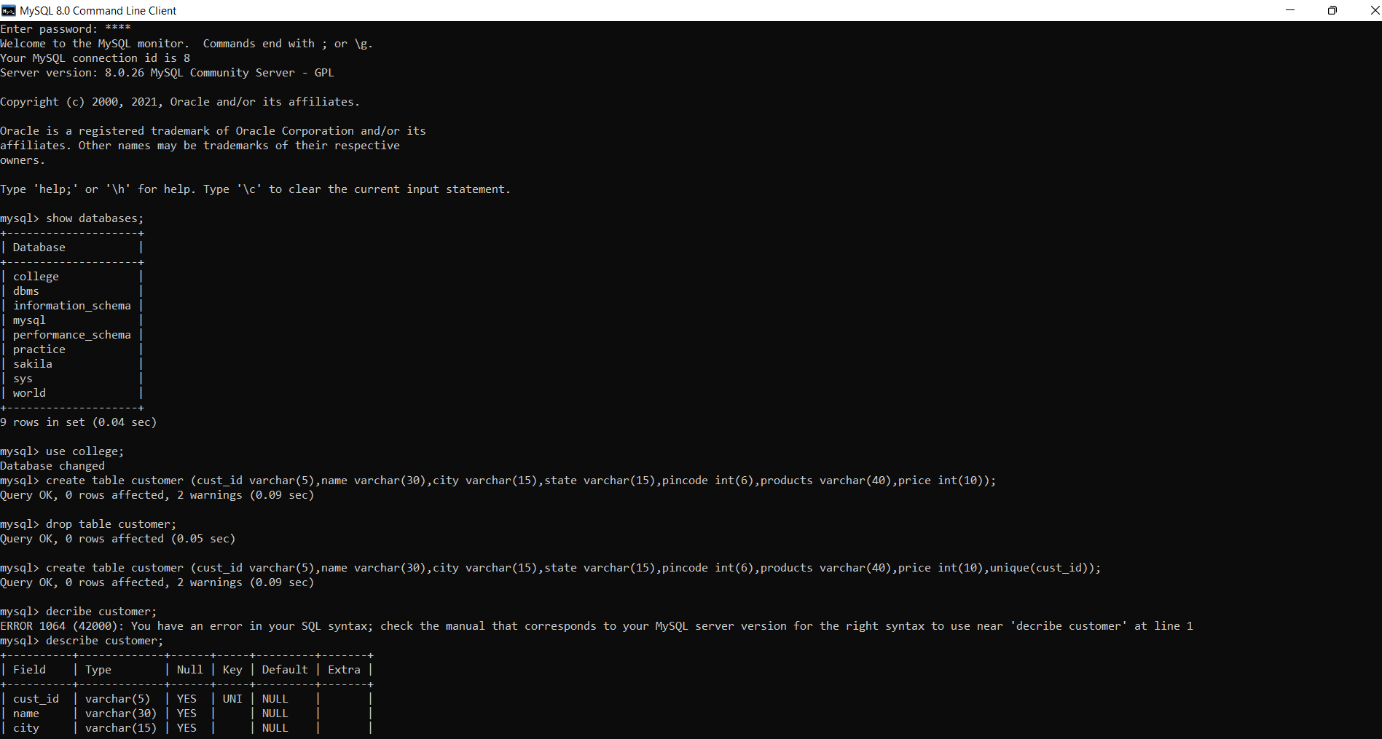

Question 2 : (inserting into table) and

Q3: (q1)

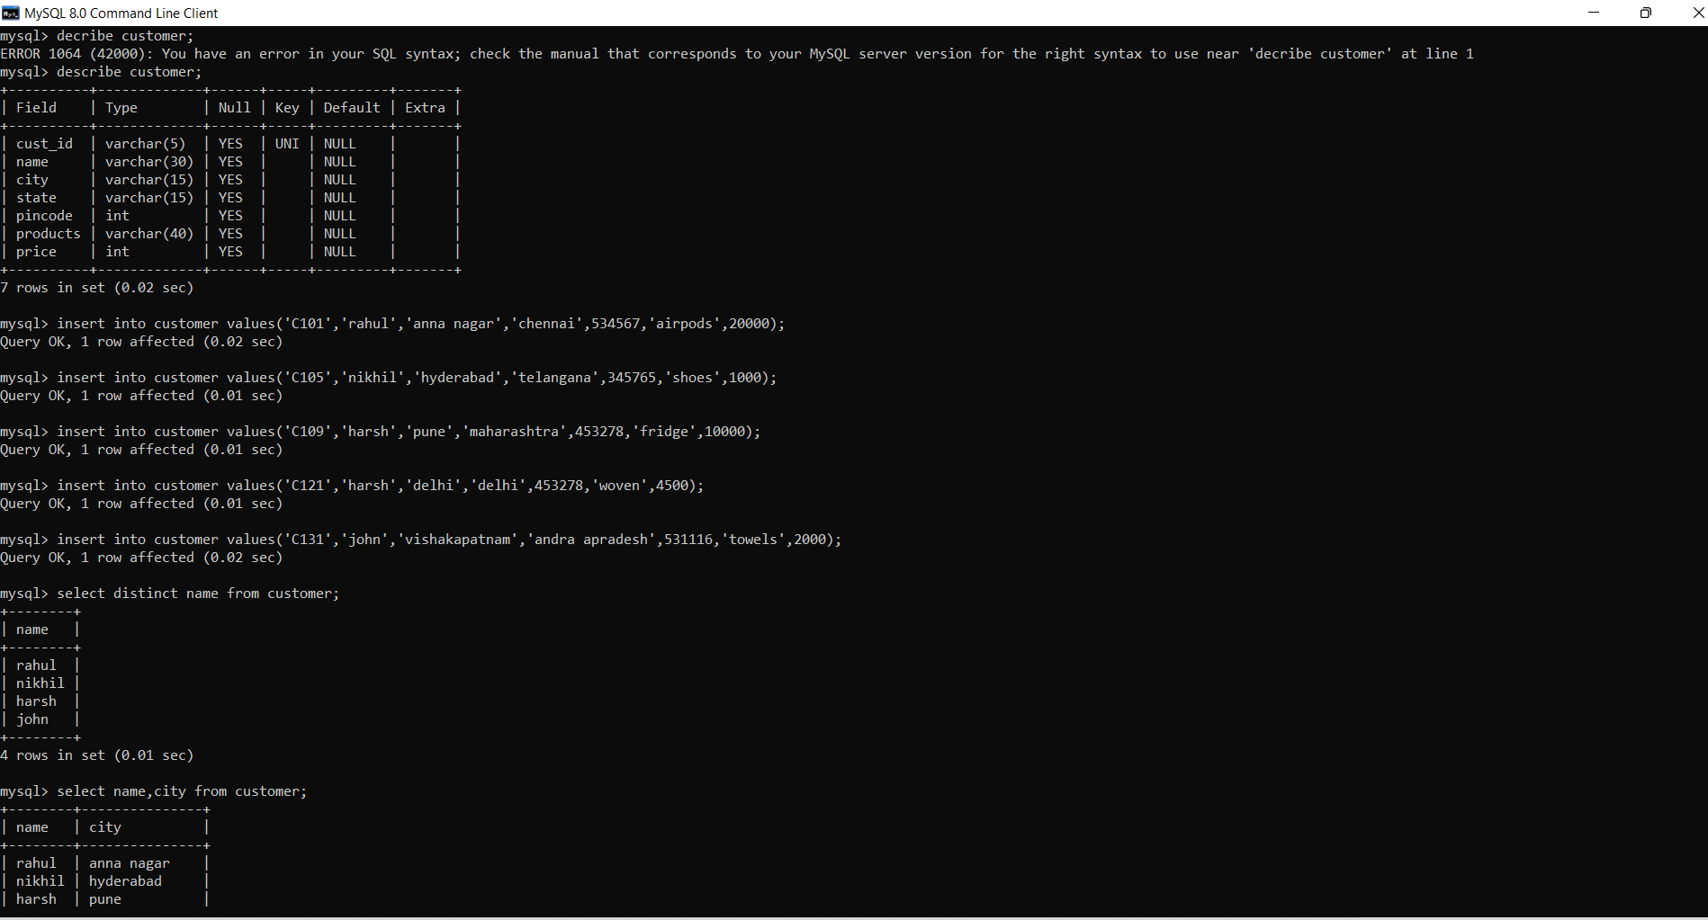

Q3: (q2 to q4)

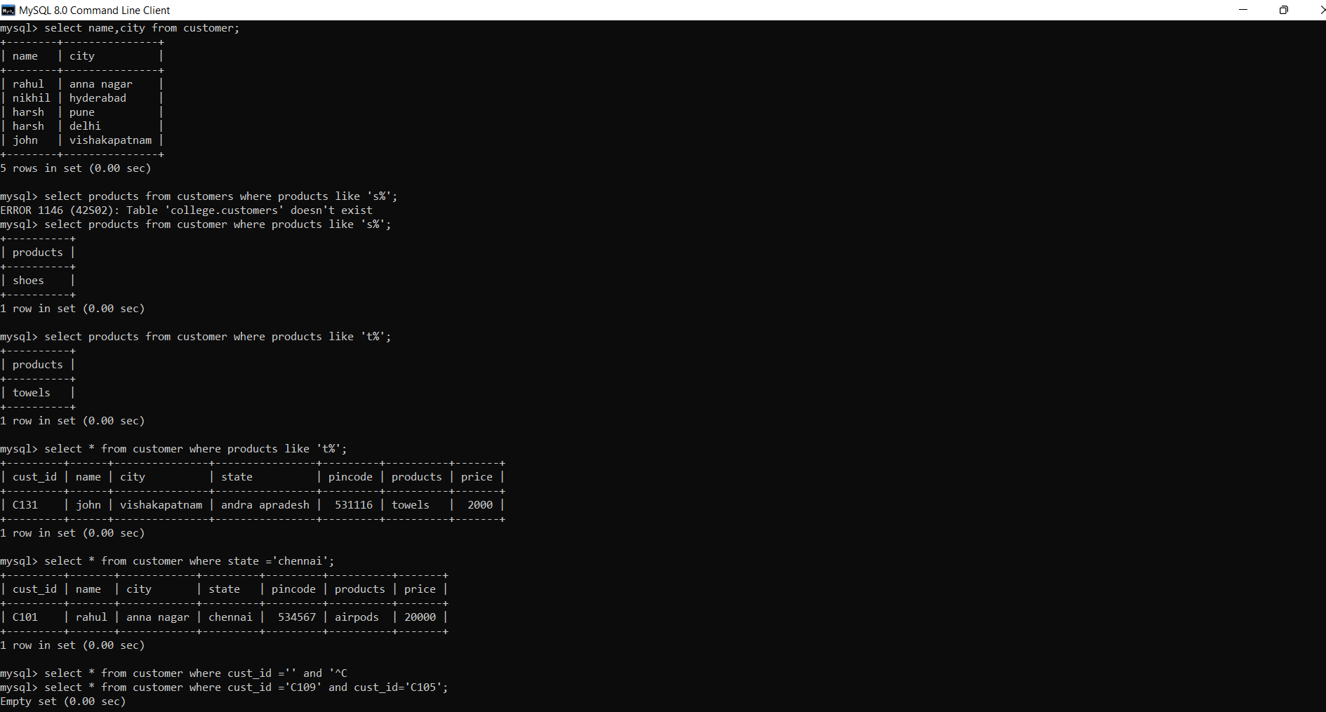

Q3: (q5 to q7)

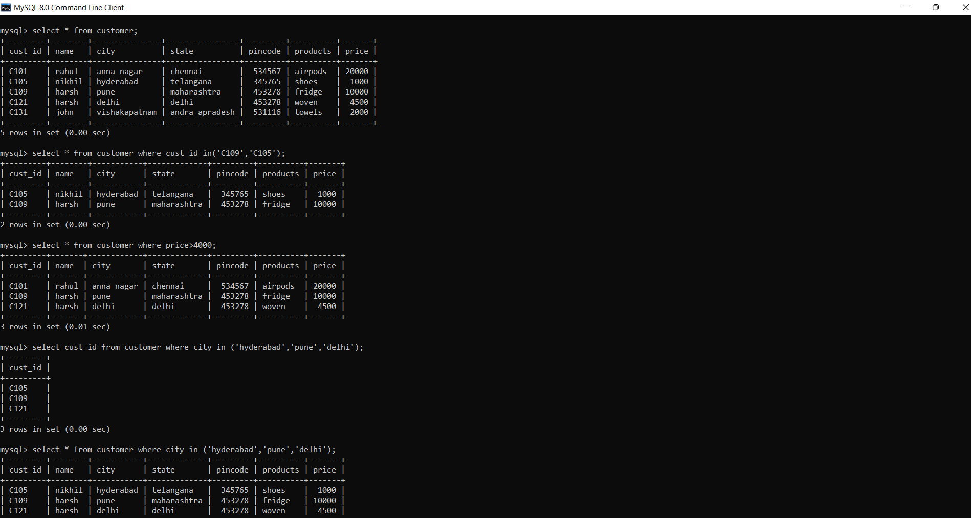

Q3 : (q7 to q10)

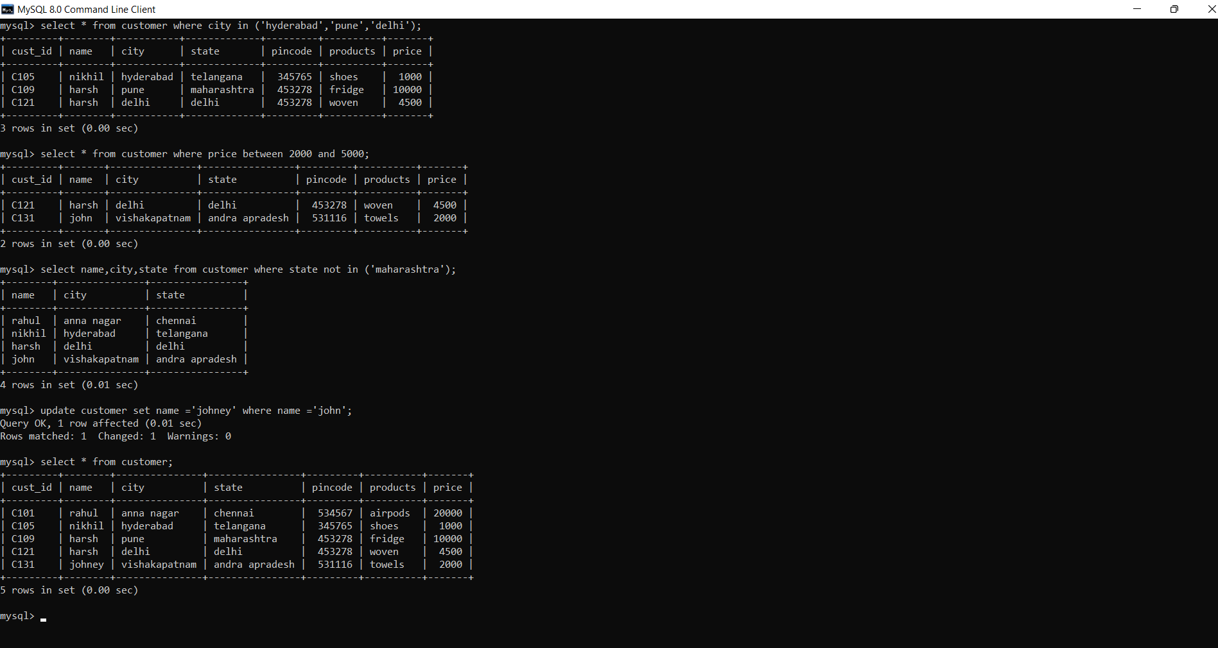

Exercise 3:

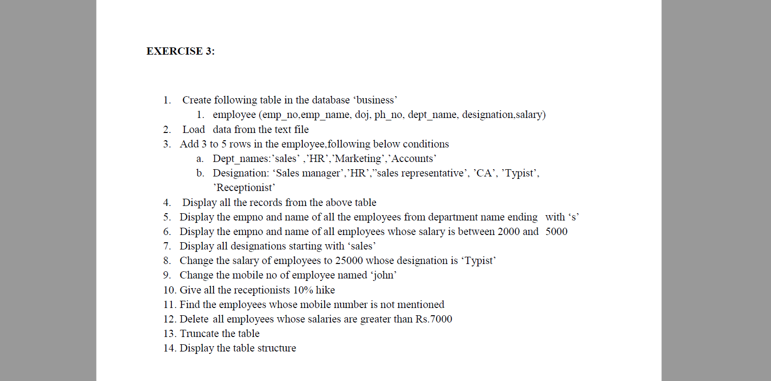

Question 1 to 3:

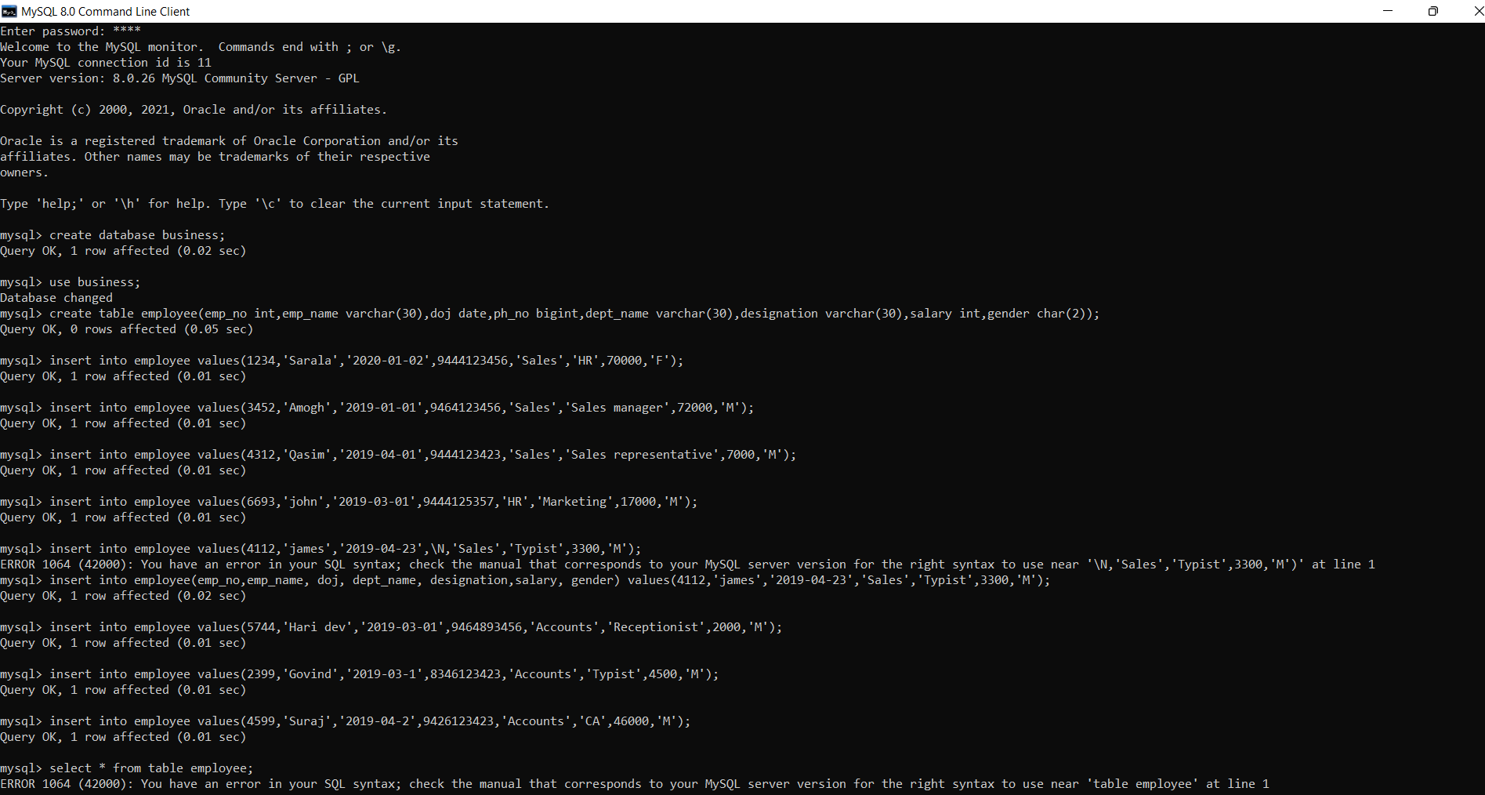

Question 4 to 6:

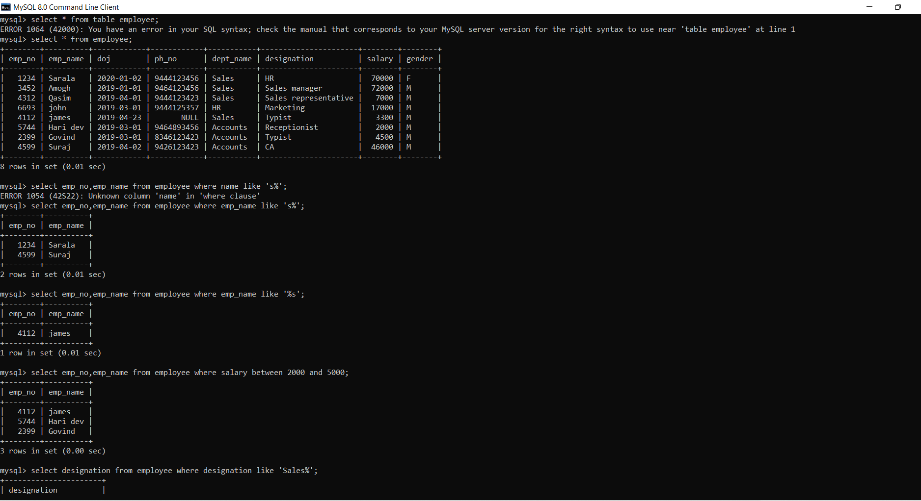

Question 7 and 8:

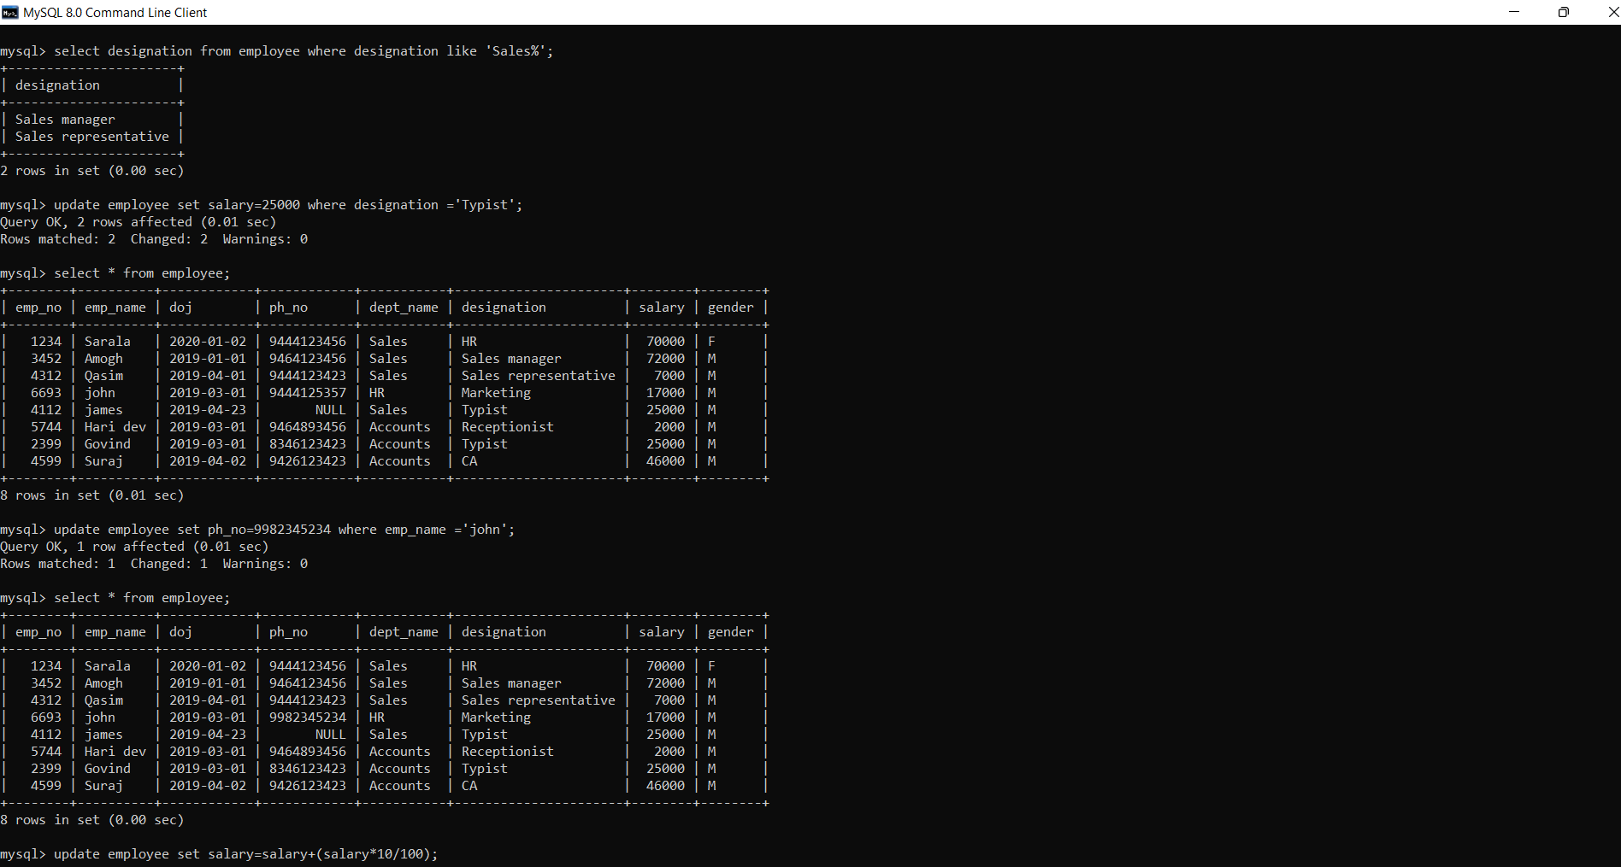

Question 9 to 12:

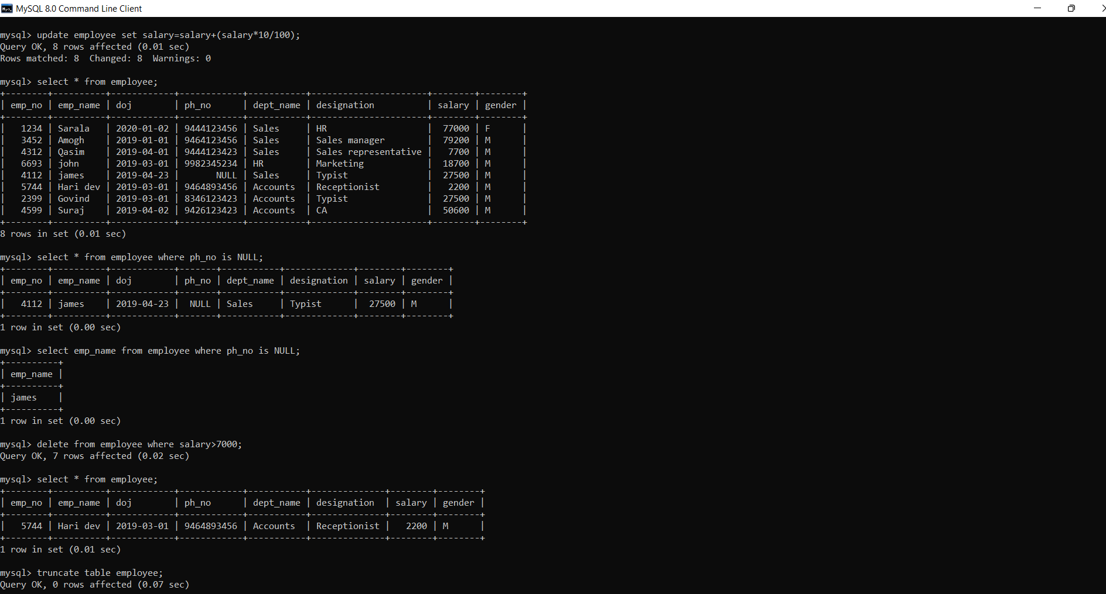

Question 13 and 14:

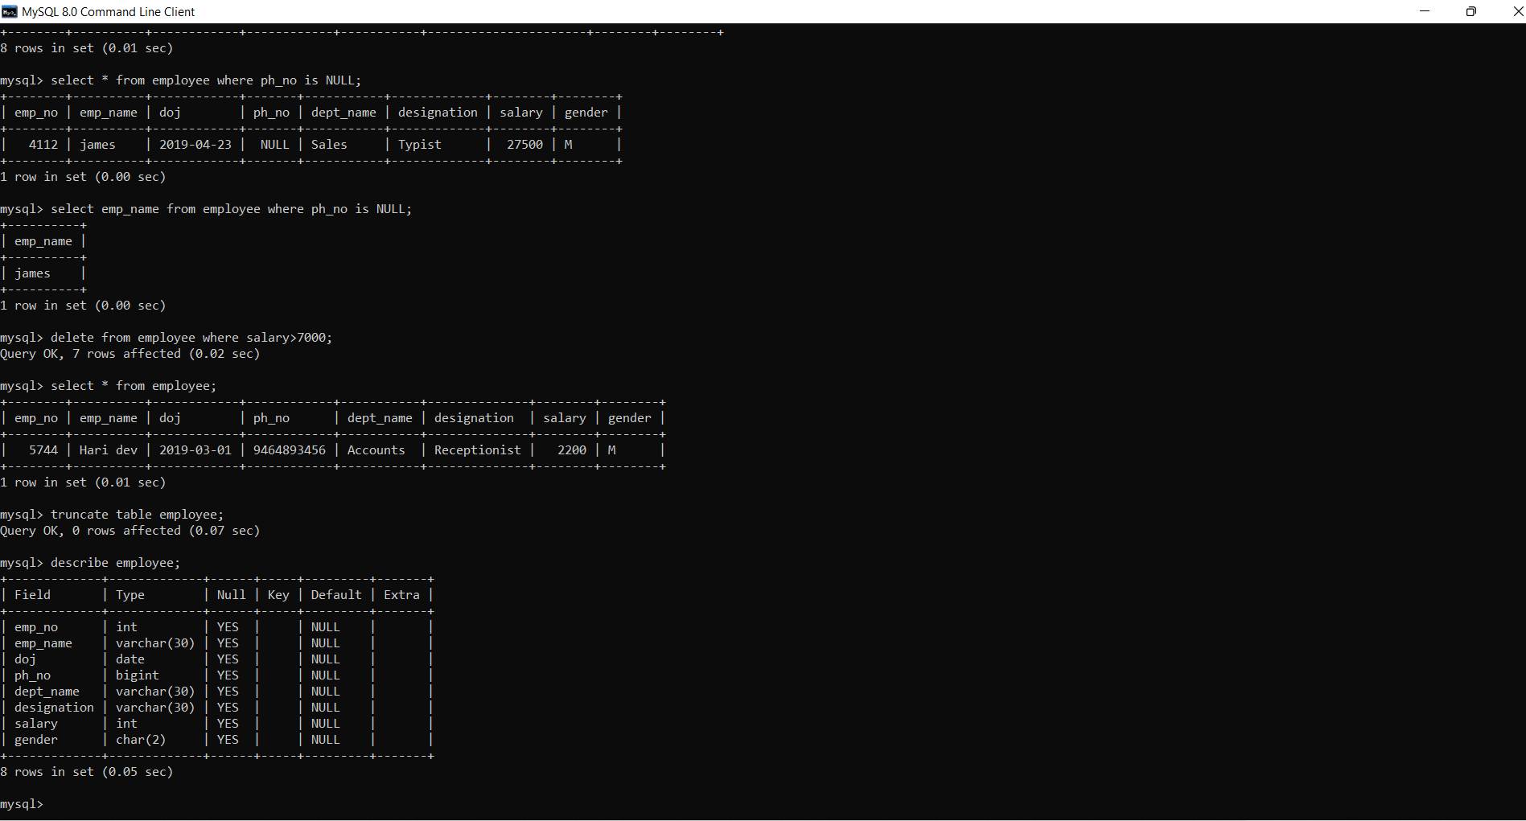

THANK YOU